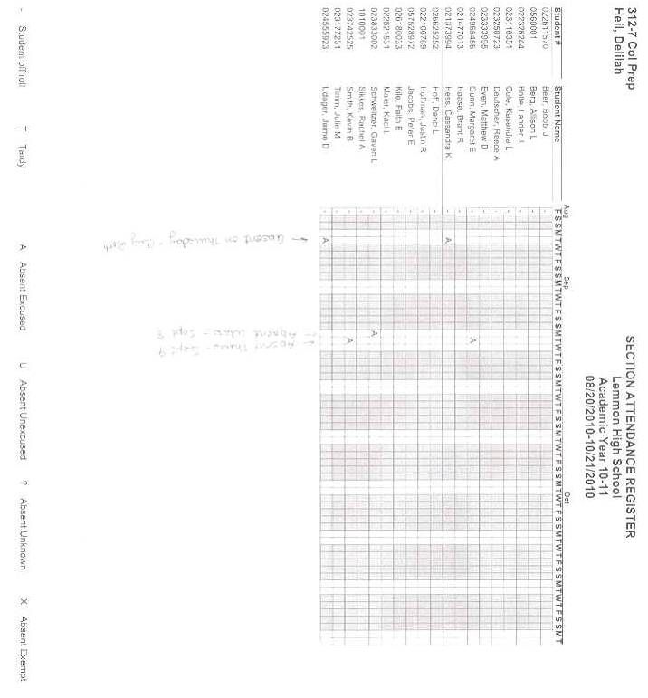

HS College Prep Attendance Register-NOT RIGHT

Grayed areas do not match our calendar non-school days. Grayed should be most Fri, Sat & Sun.

Absent Wednesday, Sept 8

Absent Thursday, Sept 9

Absent on Thursday, Aug 26



JH Calendar-Seems to be OK

This seems to be correct with attendance and the correct non-school days.